Angular 18 (released in May 2025) is the latest major version of the popular TypeScript-based web framework developed by Google.
It focuses on stability, standalone architecture, improved performance, better developer experience, and modern web standards.
What is Angular?
Angular is a front-end framework for building dynamic, single-page web applications (SPAs).
It uses:
- TypeScript for strong typing
- Components for building UIs
- Dependency Injection for modular design
- Reactive programming (with RxJS)
Angular follows the MVVM (Model-View-ViewModel) architecture and provides:
- Built-in routing
- Forms management
- State handling
- Reusable UI components

What’s New in Angular 18
A. Standalone Components (Fully Stable)
Introduced in v14, now fully stable and default in Angular 18.
No need for NgModule — components, directives, and pipes are self-contained.
@Component({
selector: 'app-home',
standalone: true,
template: `<h2>Welcome to Angular 18!</h2>`
})
export class HomeComponent {}
- Cleaner architecture
- Easier lazy loading and reuse
- Faster bootstrapping

B. bootstrapApplication API (Module-Free Bootstrapping)
Instead of using AppModule, Angular 18 uses:
bootstrapApplication(AppComponent);
This approach:
- Reduces boilerplate
- Makes apps smaller and faster
C. Improved Signals API (Reactive State Management)
Signals are a new reactivity model (alternative to RxJS for simple cases).
They make data flow predictable and efficient.
import { signal } from '@angular/core';

const counter = signal(0);
counter.set(counter() + 1);
Benefits:
- Reactive without Observables
- Simplifies change detection
- Better performance than traditional @Input()/@Output() flows
D. zoneless Change Detection (Experimental → Stable)
Angular 18 now supports Zoneless mode (no need for Zone.js).
This makes apps faster and more efficient.
bootstrapApplication(AppComponent, {
providers: [
provideZoneChangeDetection({ eventCoalescing: true })
]
});
Benefits:
- Smaller bundle size
- Better control over rendering
- Works perfectly with Signals
E. SSR & SSG with Angular Universal 18
Angular 18 introduces enhanced Server-Side Rendering (SSR) and Static Site Generation (SSG) via the new Angular CLI APIs.
ng generate app-shell
ng run my-app:prerender
Benefits:
- Faster initial load
- Better SEO
- Smoother hydration (combining server + client render)
F. Enhanced Router Features
- Route-level lazy loading for standalone components
- Type-safe route definitions
- Simplified guards and resolvers
export const routes: Routes = [
{
path: '',
loadComponent: () => import('./home.component').then(m => m.HomeComponent)
}
];
G. Typed Forms (Fully Stable)
Angular 18’s Typed Forms API gives you type-safe form controls:
const form = new FormGroup({
name: new FormControl<string>(''),
age: new FormControl<number>(0)
});
Benefits:
- Better IntelliSense
- Compile-time error checking
H. Improved Developer Tools
Angular 18 CLI includes:
- Faster builds using esbuild
- Improved hot reload support
- Better debugging messages
- Automatic import suggestions
I. Improved Performance and Bundle Optimization
- Smarter tree-shaking
- Smaller polyfills
- Better lazy-loading
- Enhanced Ahead-of-Time (AOT) compilation

J. Angular DevTools 18 Enhancements
- Debug Signals in real-time
- Monitor component lifecycles
- Inspect SSR hydration performance

How to create Angular18 App
npm install -g @angular/cli@18
ng new my-angular18-app --standalone
cd my-angular18-app
ng serve

Angular 18 Project structure
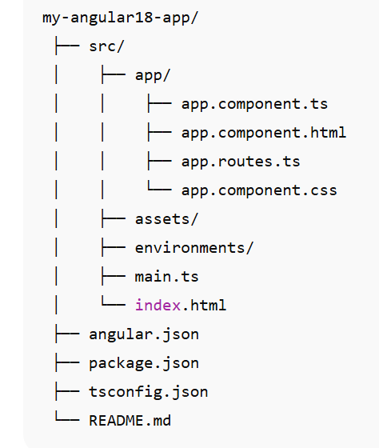

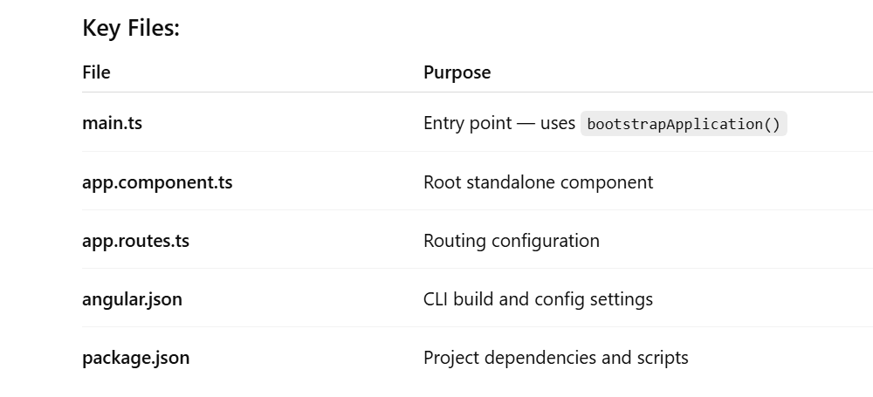

Standalone APIs (Fully Stable): Bootstrapping without NgModules
What Are Standalone APIs?
In older Angular versions, everything had to be registered inside an NgModule (like AppModule).
But from Angular 14+ and now fully stable in Angular 18, you can build complete Angular apps without any NgModules.
You just use standalone components, standalone directives, and standalone pipes — and bootstrap them directly.

Traditional Way (Before Angular 18)
Main.ts
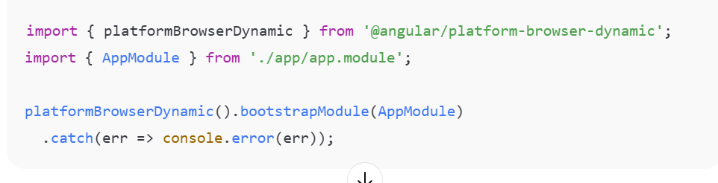

App.module.ts
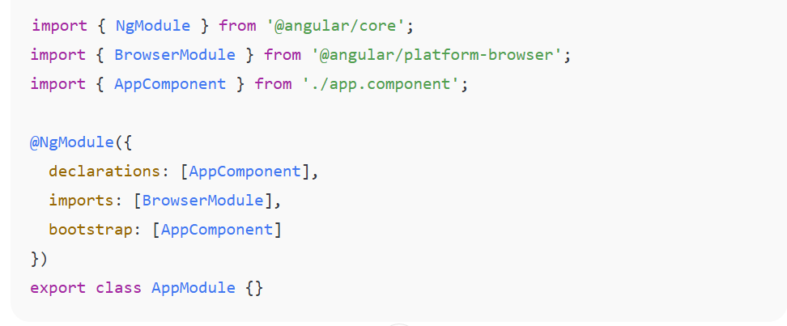

Enhanced Hydration for SSR Applications
What Is Hydration in Angular?
When using Server-Side Rendering (SSR) (via Angular Universal), the app’s initial HTML is rendered on the server and sent to the browser.
Then Angular runs on the client and hydrates — meaning it attaches event listeners and change detection to the existing DOM rather than recreating it.
Without hydration, Angular re-renders the whole DOM again, wasting time and losing server-rendered HTML benefits.
What Is Enhanced Hydration?
Enhanced Hydration (introduced in Angular 17+) is the next-generation hydration system.
It is smarter, more efficient, and avoids unnecessary DOM manipulation.
Benefits:
- Reduces Cumulative Layout Shift (CLS)
- Improves Time to Interactive (TTI)
- Avoids double-rendering on the client
- Fully compatible with Signals and Standalone Components
- Automatically skips unchanged parts of the DOM

ng new hydration-demo --ssr
cd hydration-demo
Run the SSR server ----- npm run dev:ssr

Its default enabled in Angular 18
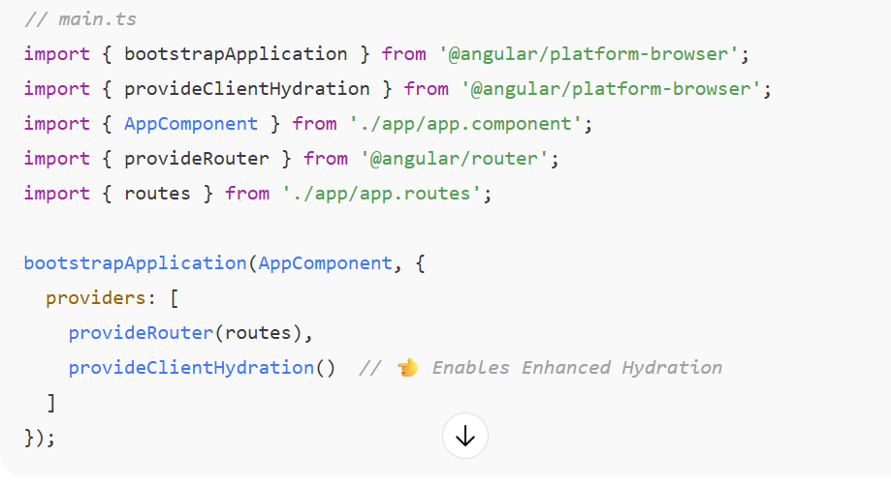

ng new hydration-demo –ssr
Run the SSR server: npm run dev:ssr
Angular 18+ has enhanced hydration enabled by default,
but you can explicitly configure it using the new provideClientHydration() API.

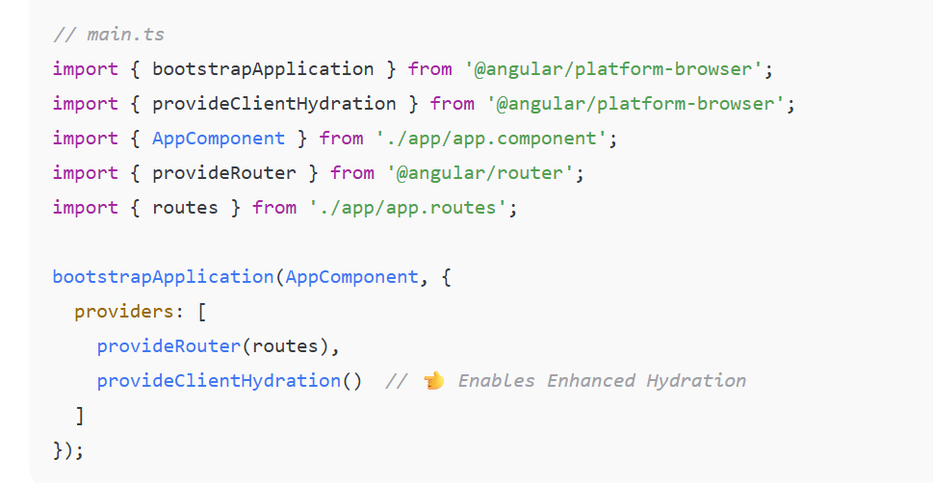

Angular automatically detects SSR markup and hydrates the DOM without re-rendering it.
Main.server.ts
app.config.server.ts
main.ts
run server --- npm run dev:ssr
ng add @angular/ssr
npm install @angular/ssr @nguniversal/builders

Built-in Control Flow (Stable): @if, @for, @switch, @empty
Before Angular 17, we used structural directives like:
*ngIf, *ngFor, *ngSwitch
These worked, but had some drawbacks:
- Verbose syntax
- Performance overhead
- Harder to read nested conditions
So Angular introduced a new, built-in syntax:
@if, @for, @switch, @empty
These are compiler-level features (not directives), meaning they are:
Faster
More readable
Type-safe

@if

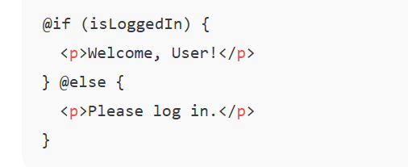
@for
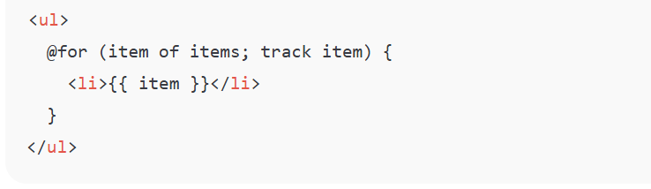

@switch
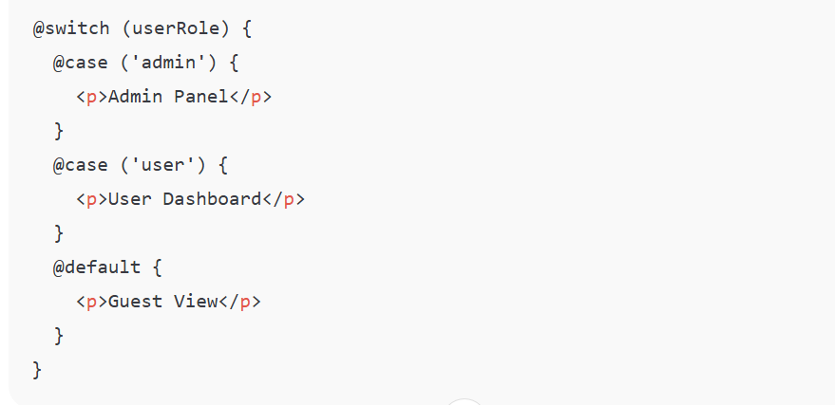

@empty — Handle Empty Collections
Used with @for to render fallback UI when a list is empty.
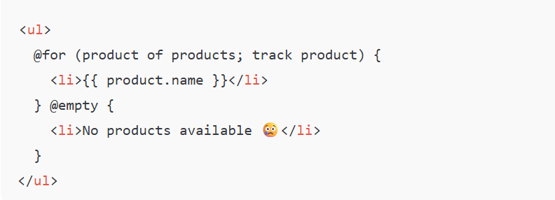
<p>hi</p>
Self-closing Tags: Full HTML5 compatibility
In HTML5, self-closing tags are shorthand for elements that don’t need both an opening and closing tag.
Example (HTML5 syntax):
<br />
<img src="logo.png" />
<input type="text" />
<hr />
These tags close themselves, unlike normal HTML elements which require both open and close tags:
<app-home></app-home>
Angular 18 fully supports self-closing tags, matching HTML5 semantics.
<app-home />
Instead of <app-home></app-home>

Component Lifecycle Hooks + Angular 18 Refinements
What Are Lifecycle Hooks?
Every Angular component has a lifecycle — from creation to destruction.
Lifecycle hooks are special methods that let you run code at specific points in that lifecycle.
ull Lifecycle Flow (Angular Component Lifecycle)
Here’s the order of hooks called for a component:
constructor()
ngOnChanges()
ngOnInit()
ngDoCheck()
ngAfterContentInit()
ngAfterContentChecked()
ngAfterViewInit()
ngAfterViewChecked()
ngOnDestroy()

Detailed Explanation of Each Hook
Hook | Purpose | Called When
constructor() | Initialize variables / inject dependencies | When component instance is created
ngOnChanges() | Respond to input property changes | Before ngOnInit, whenever @Input changes
ngOnInit() | Initialization logic (fetch data, setup UI) | Once after first ngOnChanges
ngDoCheck() | Custom change detection logic | During every change detection run
ngAfterContentInit() | Work with projected <ng-content> | After content is inserted into the component
ngAfterContentChecked() | Check for changes in projected content | After every content check
ngAfterViewInit() | Access child components or view DOM | Once after component view initialization
ngAfterViewChecked() | Respond to changes in child views | After each view check
ngOnDestroy() | Cleanup logic (unsubscribe, remove listeners) | Just before component is destroyed

Angular 18 Refinements and New Additions
Angular 18 introduces new functions related to rendering, particularly useful when moving towards zoneless change detection:
- afterNextRender: A function (not a class method) that runs a callback once after all components have been rendered to the DOM in the next render cycle. This is suitable for performing one-off manual DOM operations or integrating browser-specific libraries that rely on the DOM being ready.
- afterEveryRender: Similar to afterNextRender, but the callback runs after every subsequent render cycle. This is for operations that need to react to continuous changes in the DOM.
Both afterNextRender and afterEveryRender must be called in an injection context (typically the constructor) and are executed only in the browser, not during server-side rendering (SSR). They replace the need to use NgZone.onStable for timing code execution after rendering in zoneless applications.
Data Binding Patterns and Performance Optimizations
Angular 18 utilizes the same core data binding patterns as previous versions, while emphasizing performance optimizations through features like OnPush change detection, the input() function, the new model() binding, and experimental zoneless change detection.
Data Binding Patterns in Angular 18
Angular supports the following primary data binding patterns, which remain consistent in version 18:
Binding Type | Syntax | Data Flow Direction | Description
Interpolation | {{ value }} | Component → View (One-way) | Displays component data as a string in the template.
Property Binding | [property]="value" | Component → View (One-way) | Binds a component's property to a DOM element's property (e.g., [src], [disabled]).
Event Binding | (event)="handler()" | View → Component (One-way) | Listens for DOM events (e.g., (click), (input)) and triggers a component method.
Two-Way Binding | [(ngModel)]="value" or [(model)]="value" | Component ↔ View (Bidirectional) | Synchronizes data between the component and input elements in real-time. Requires FormsModule.
Performance Optimizations in Angular 18
Angular 18 introduces several performance-focused features and best practices for data binding:
- input() function and model() binding: Angular 18 introduces an input() function as an optimized alternative to the @Input() decorator. The new model() function specifically sets up an optimized two-way binding mechanism, creating an input property and a corresponding nameChange output event, which enhances developer experience (DX) and performance, especially when moving towards a zoneless architecture.
- OnPush Change Detection Strategy: This is a key optimization. By default, Angular runs change detection across the entire component tree on most events. Setting changeDetection: ChangeDetectionStrategy.OnPush tells Angular to only check a component when its input properties change (by reference), an event originates within the component, or change detection is manually triggered, significantly reducing unnecessary checks.
- Zoneless Change Detection (Experimental): Angular 18 emphasizes preparation for a fully zoneless mode. In this mode, components directly notify Angular of changes without relying on Zone.js, allowing for more fine-grained and efficient change detection, further improving performance.
- trackBy in *ngFor and @for: When rendering large lists, use a trackBy function to help Angular identify which items have changed. This prevents the entire DOM list from being re-rendered when only a few items are updated, minimizing DOM manipulations.
- Avoid Expensive Operations in Templates: Do not use complex methods or getters within template expressions ({{ ... }}). These operations can be re-evaluated frequently during change detection cycles, potentially causing performance bottlenecks.
- Use Pure Pipes: Pure pipes only re-evaluate when their input data changes, preventing unnecessary recalculations during every change detection run.
- Pass Observables Directly: When using OnPush and libraries like rxAngular, pass observables directly to components and use the async or push pipe. This allows the pipe to manage subscriptions automatically and helps ensure that only the affected component is re-rendered.

Modern Angular18 Features
Required Inputs: @Input({ required: true, alias: 'name' })
The @Input() Decorator
In Angular, @Input() lets parent components pass data to child components.
Example (classic syntax):
@Input() username!: string;
Then in the parent template:
<app-user [username]="'Remya'"></app-user>
Works fine — but if you forget to pass username, the component still loads with undefined,which can lead to runtime errors.

Angular 18 Enhancement: Required Inputs
Angular 18 (and 17+) allows you to mark input properties as required:
@Input({ required: true }) username!: string;
Now Angular will enforce that this input must be provided in the parent template.
If input is provided:
<app-user [username]="'Remya'"></app-user>
→ Works perfectly.
If input is missing:
<app-user></app-user>
Angular compiler throws a template error:
Error: Required input 'username' from component 'app-user' is missing.
This helps catch bugs early during template compilation.

Improved Tree-shaking and Bundle Optimization
What Is Tree-Shaking?
Tree-shaking is a build optimization technique used by Angular (via the Angular CLI + Webpack + ESBuild) to remove unused code from your final production bundle.

If you import a library but use only one function:
import { add, multiply, divide } from './math-utils';

console.log(add(2, 3));
Tree-shaking ensures only add() is kept.
multiply and divide are removed from the production bundle.

Comparing Bundle Sizes
Angular Version | App Type | Production Bundle Size
Angular 16 | Medium app (10 components) | ~260 KB
Angular 18 | Same app (standalone) | ~175 KB
Difference |  | 🔻 ≈ 30–35% reduction

Lazy Loading and Bundle Splitting
Angular 18’s build system splits bundles intelligently:
- Eager bundle: Main + critical components
- Lazy bundles: For routes/components loaded on demand

export const routes = [
{ path: '', component: HomeComponent },
{ path: 'about', loadComponent: () => import('./about/about.component').then(c => c.AboutComponent) }
];
Only loads AboutComponent when you navigate to /about.
This makes the initial bundle smaller and improves page load speed.

Bundle Analyzer
ng build --configuration production --stats-json
Then visualize bundle composition:
npx source-map-explorer dist/<your-app>/browser/main.*.js

Angular DevTools v18 Integration
Angular DevTools is a browser extension for Chrome and Edge that helps you:
- Inspect Angular components
- Monitor data bindings
- Debug dependency injection
- Profile change detection cycles
- Visualize signal updates and reactive flows (Angular 18+)
It’s the official Angular debugging tool, replacing the older Augury extension.

Install Angular DevTools v18
🔹 For Chrome:
Chrome Web Store – Angular DevTools
🔹 For Microsoft Edge:
Edge Add-ons – Angular DevTools
Once installed, it adds a new “Angular” tab to Chrome DevTools.

Key Tabs in Angular DevTools
🔹 Components Tab
- Displays the component tree
- Lets you inspect @Input and @Output properties
- Supports standalone components and alias-based @Input()
- Displays signal values and their real-time updates
Example:
If your component has:
@Input({ alias: 'username' }) name!: string;
You’ll see username as the property in DevTools.
🔹 Injector Graph Tab
Visualizes Angular’s Dependency Injection:
- Shows what services are provided at each level
- Helps trace circular dependencies or unexpected injections
🔹 Signals Tab (New in Angular 18)
This is one of the biggest additions
Shows how signals, computed, and effects interact.
Example:
count = signal(0);
double = computed(() => this.count() * 2);
effect(() => console.log(this.double()));
DevTools will visualize this dependency chain:
count → double → effect
You can even watch how updates flow through signals in real time.
🔹 Profiler Tab
Analyzes app performance and change detection.
You can:
- Record app interactions
- See which components re-rendered
- Measure rendering time
- Identify inefficient data bindings
Now supports:
- Signal-triggered updates
- Zoneless profiling
- Lazy-loaded component timelines

Material Design 3 Overview and Setup
What is Material Design 3?
Material Design 3 (MD3), also called Material You, is the latest version of Google’s Material Design system.
It focuses on personalization, accessibility, and visual harmony — adapting to each user’s device, wallpaper, and theme.

Setting up Angular Material 3 in Angular 18
Step 1: Create a new Angular 18 app
ng new material3-demo --standalone
cd material3-demo

Step 2: Install Angular Material (v18+)
ng add @angular/material
This command:
- Installs Angular Material v18
- Automatically enables Material Design 3
- Adds global theme styles
- Imports the default typography and animations
You’ll see a prompt like:
? Choose a prebuilt theme name, or "custom" for a custom theme:
> Indigo/Pink (Material Design 3)
Purple/Green (Material Design 3)
Pink/BlueGrey (Material Design 3)
Custom
Select any MD3-based theme.
Step 3: Verify Angular Material version
Check your package.json:
"@angular/material": "^18.0.0"

Step 4: Confirm Styles in angular.json
You’ll find something like:
"styles": [
"src/styles.css"
],
"assets": [
"src/favicon.ico",
"src/assets"
]
Angular CLI automatically adds Material’s global styles.

